/*Ashok IPBC ETL Process Lab 7.13.19*/

Homework – Create a basic SSIS Package to enter the files provided in “ETL_Diagram Section Files” to a

new Database called Curriculum. The SQL Script will be executed within SSIS in a SQL Task (The script

may be too big to use in a SQL Task. In that case, find another alternative such as putting the script

inside a Stored Procedure.) The Excel file will be loaded within SSIS as well. The end result will be 6

tables loaded to the new Database.

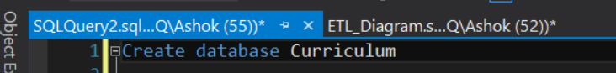

We need to create new database as Curriculum as shown in above image

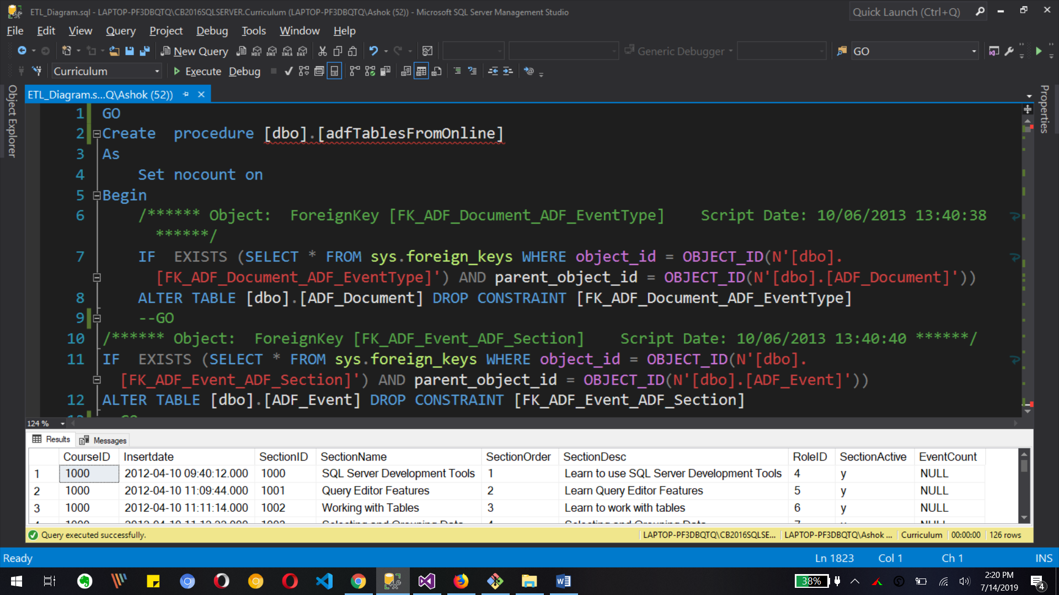

First we set our big query in to stored procedure so we can execute that stored procedure from SSIS. We have created dbo.adfTablesFromOnline stored procedure for that.

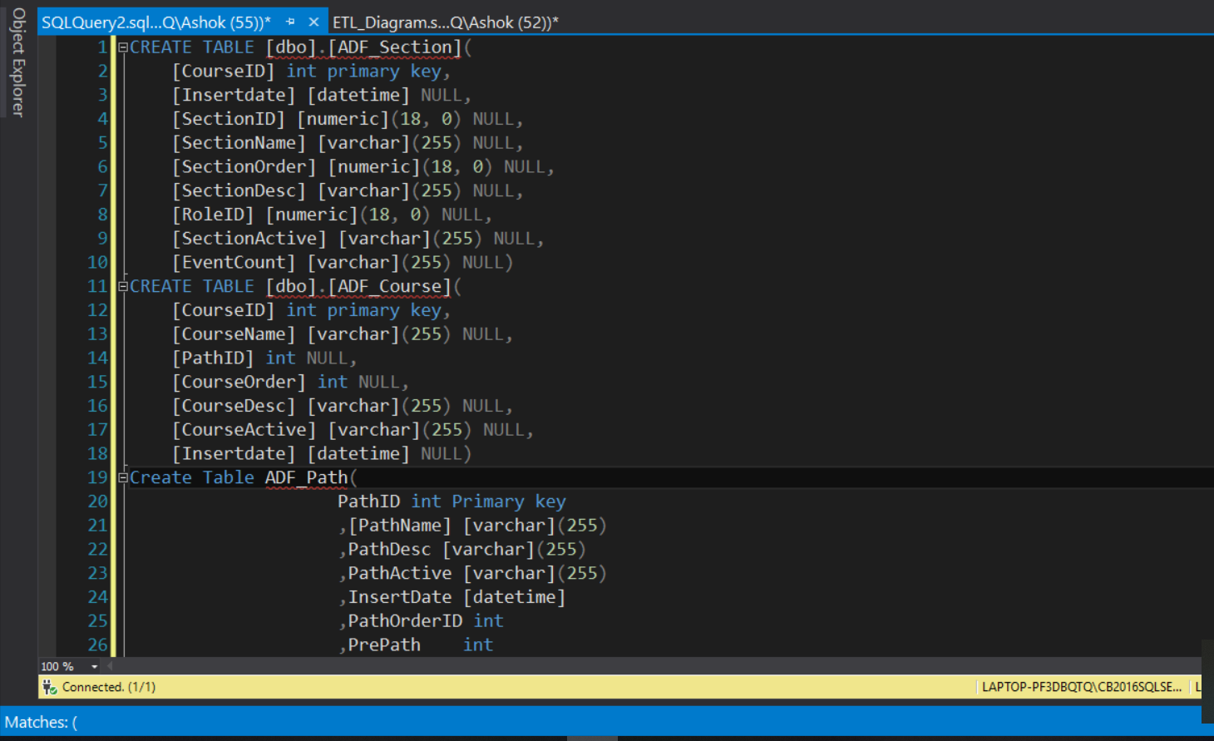

We need to create 3 tables [dbo].[ADF_Path], [dbo].[ADF_Course], [dbo].[ADF_Section] in created database as shown in above image.

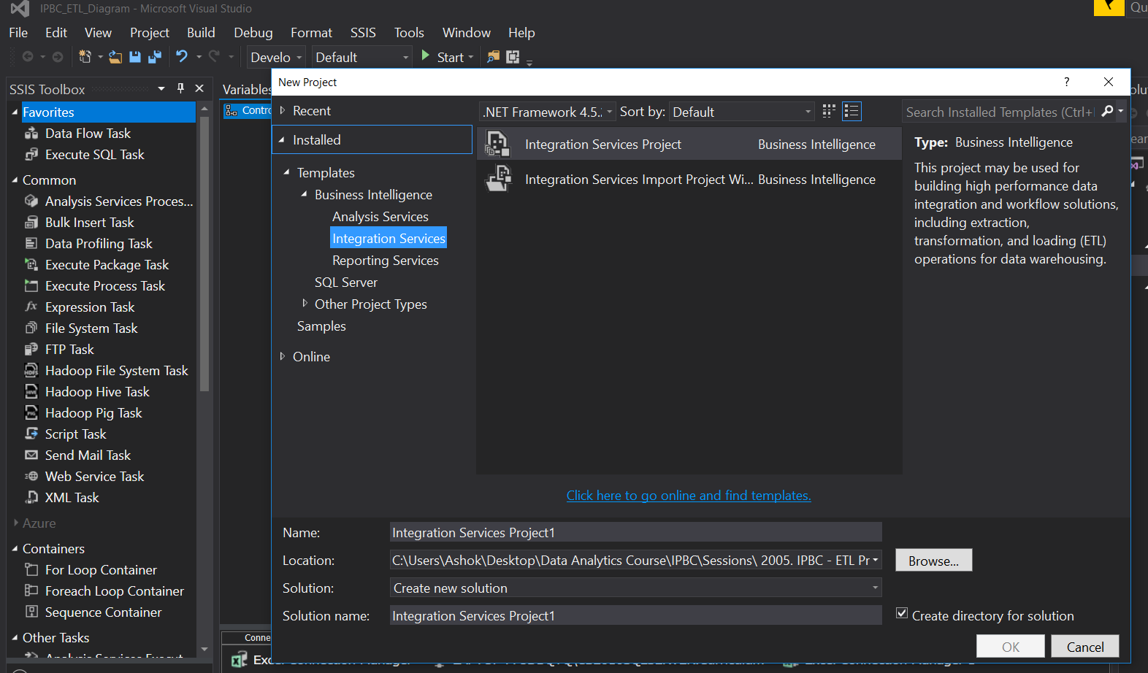

Now we need to create new SSIS project in visual studio as shown in above image with new project from File tab.

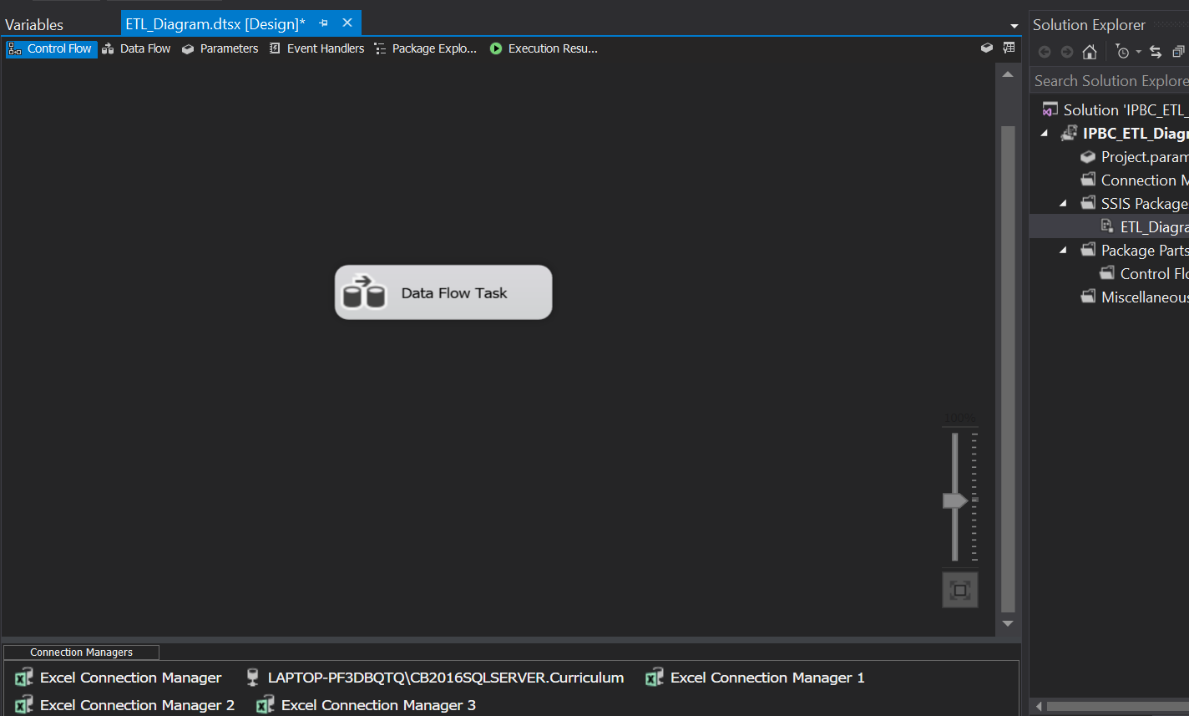

Now we need to create Dataflow task in control flow of created project’s package.

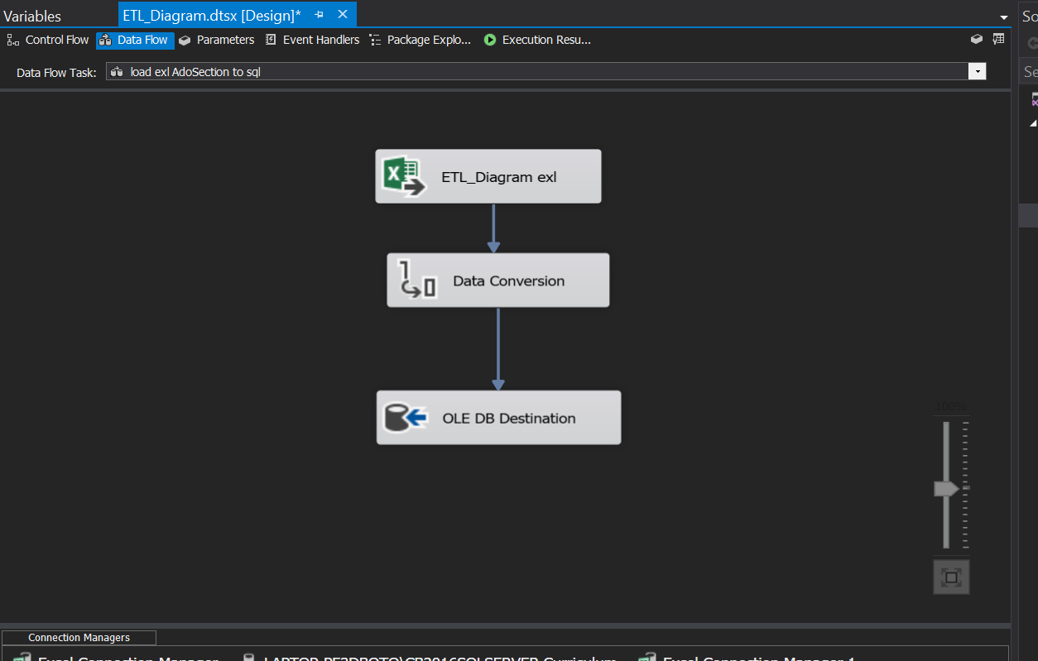

We need to have excel file source, data conversion transformation and ole db destination in data flow. Excel file Source is to get data from excel file.

Data conversion is for converting excel data (Unicode to non Unicode) to SSIS data type.

And final Ole db destination for transferring data to sql server’s created tables

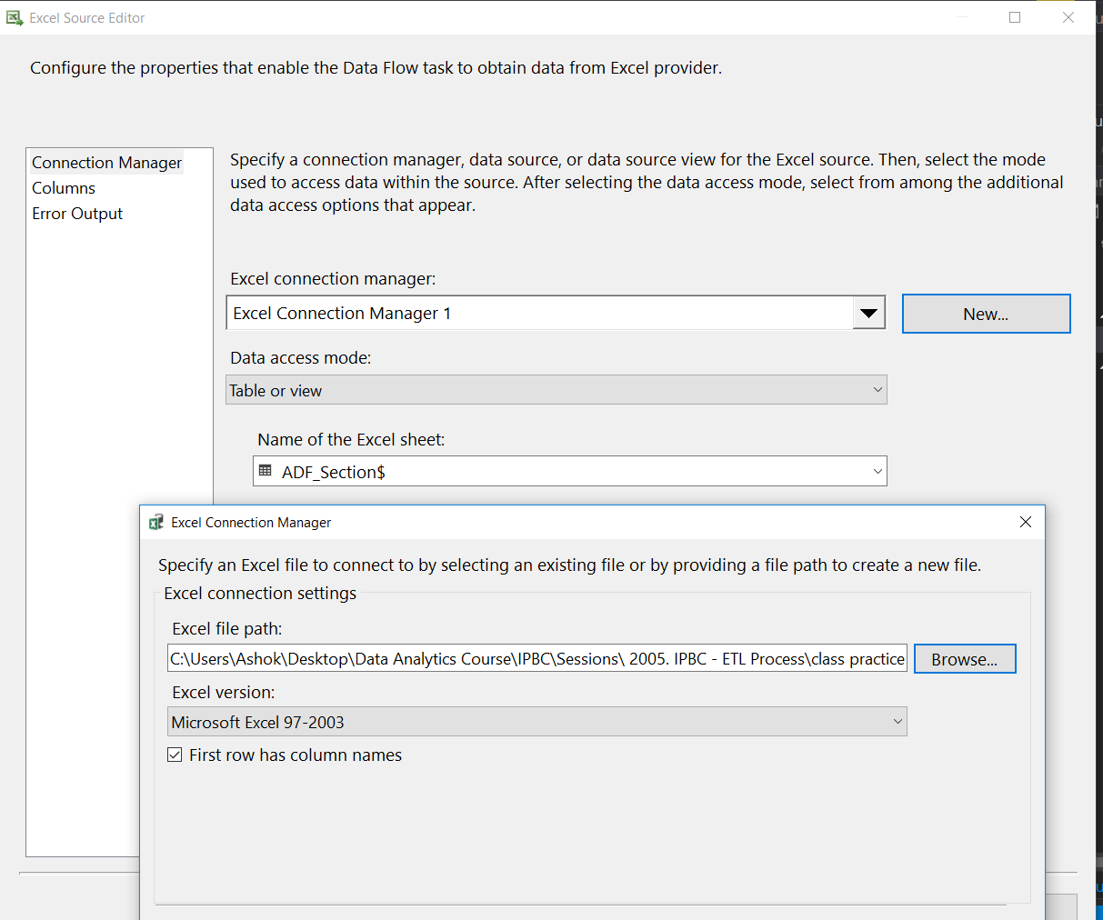

The excel source need to be edited for connection manager to excel file from computer.

And then we need to select which sheet we need to load as shown in image

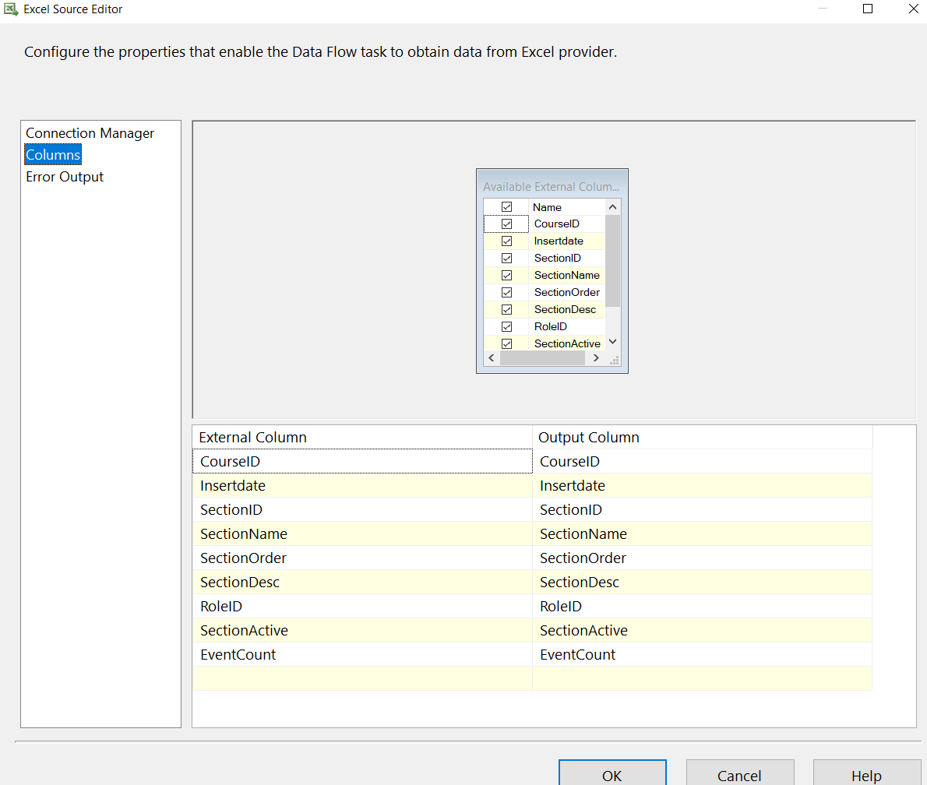

Now in same window for excel source editor we select all columns shown in image and click ok.

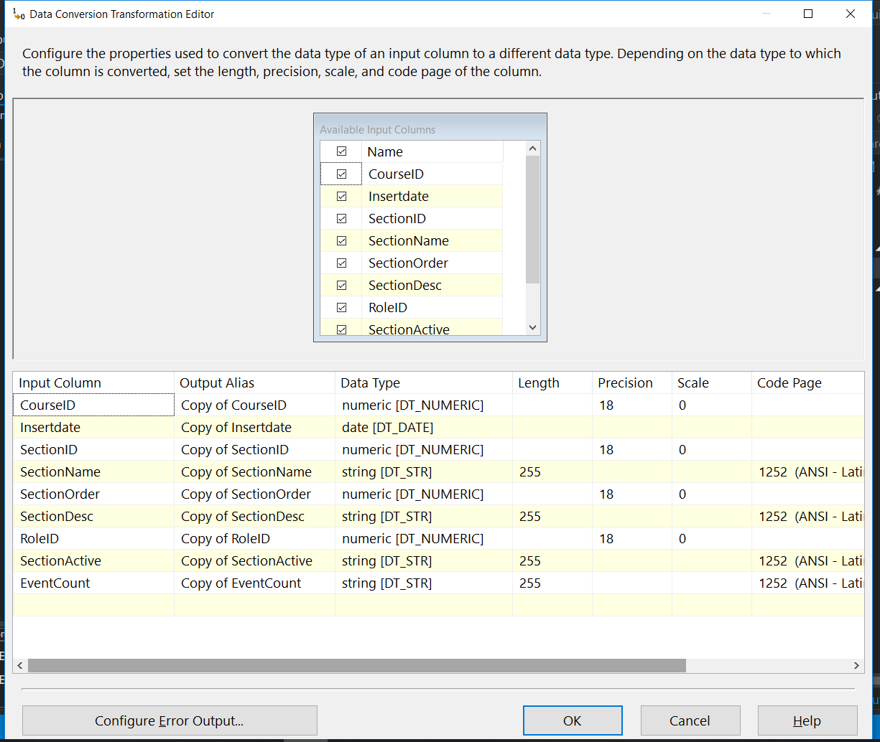

Now in data conversion editor we need to convert all non Unicode datatype to Unicode datatype as shown in image.

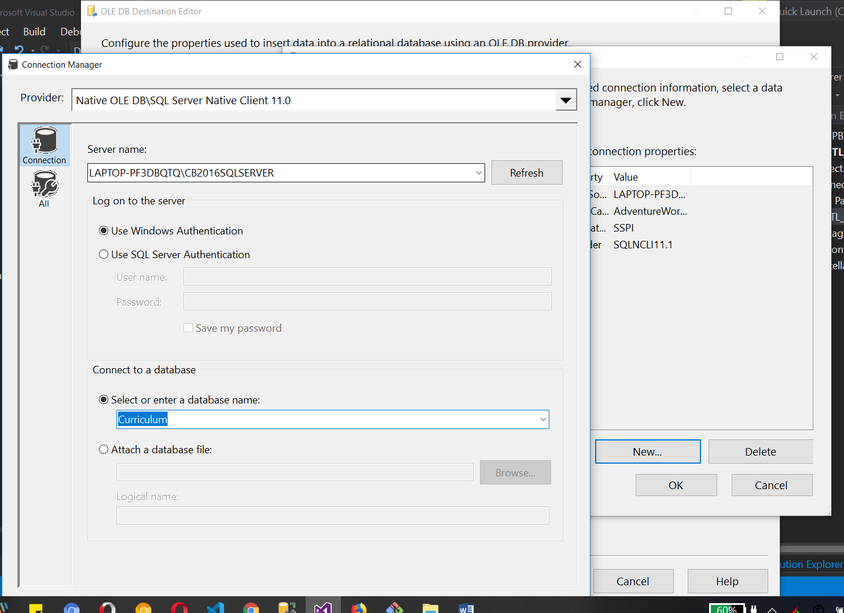

In Ole db destination editor we need connection to server and the database where we want to transfer all excel file’s data. So we need to create connection manager for server and database as above image.

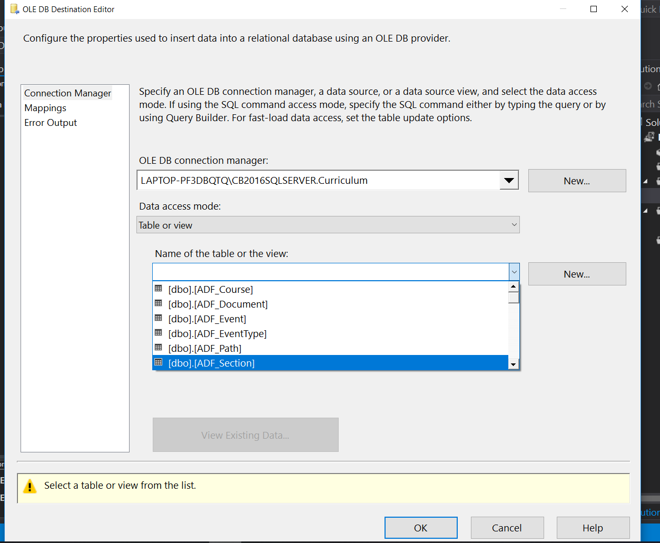

Now we need to select table from that database so we can load excel file data to that table.

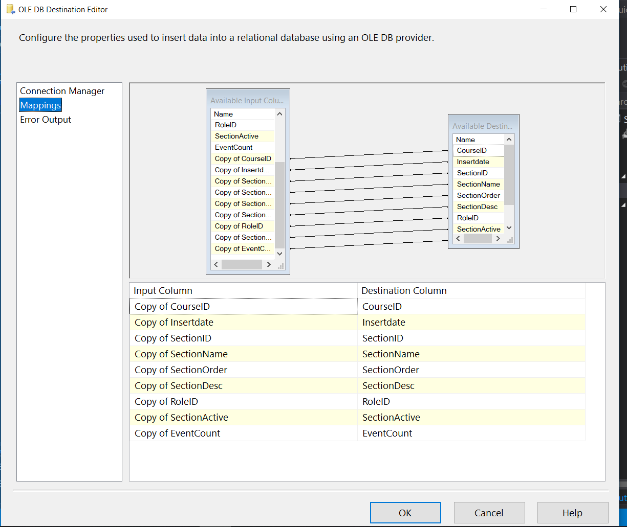

Now we map columns from input to destination as shown in above image and click ok.

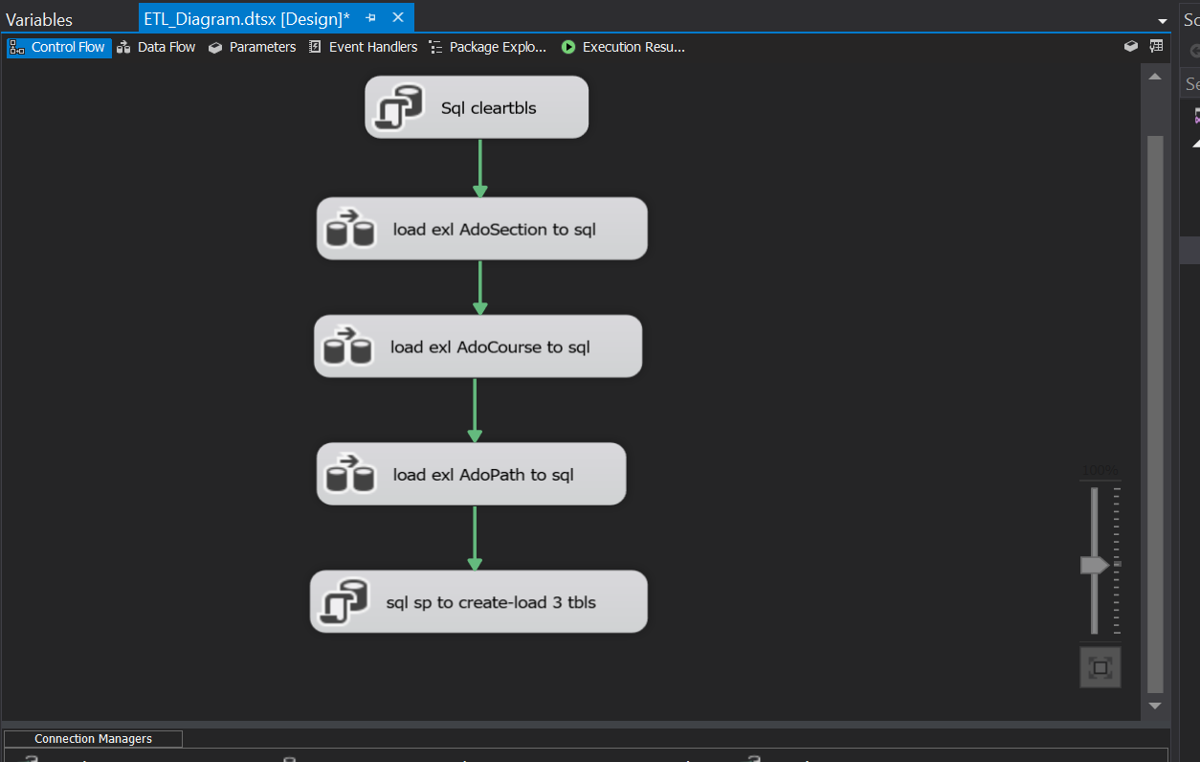

Now we can get two more data flow task as first one for Ado Course and Ado Path excel files/sheets to load them in respective table of created database.

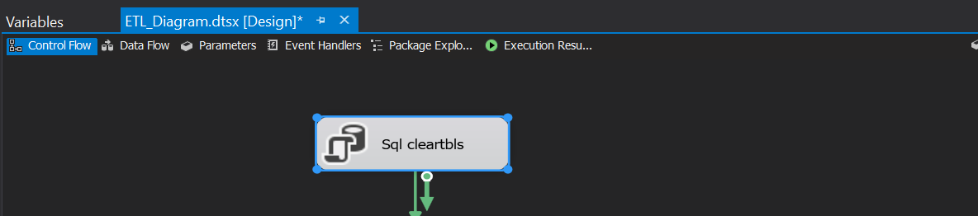

Now we can add one sql task to clear tables and drop tables so SSIS package can work as many times we want without filling duplicate data in table. We put this task at the top of the stack so it do its work before and loading data to tables.

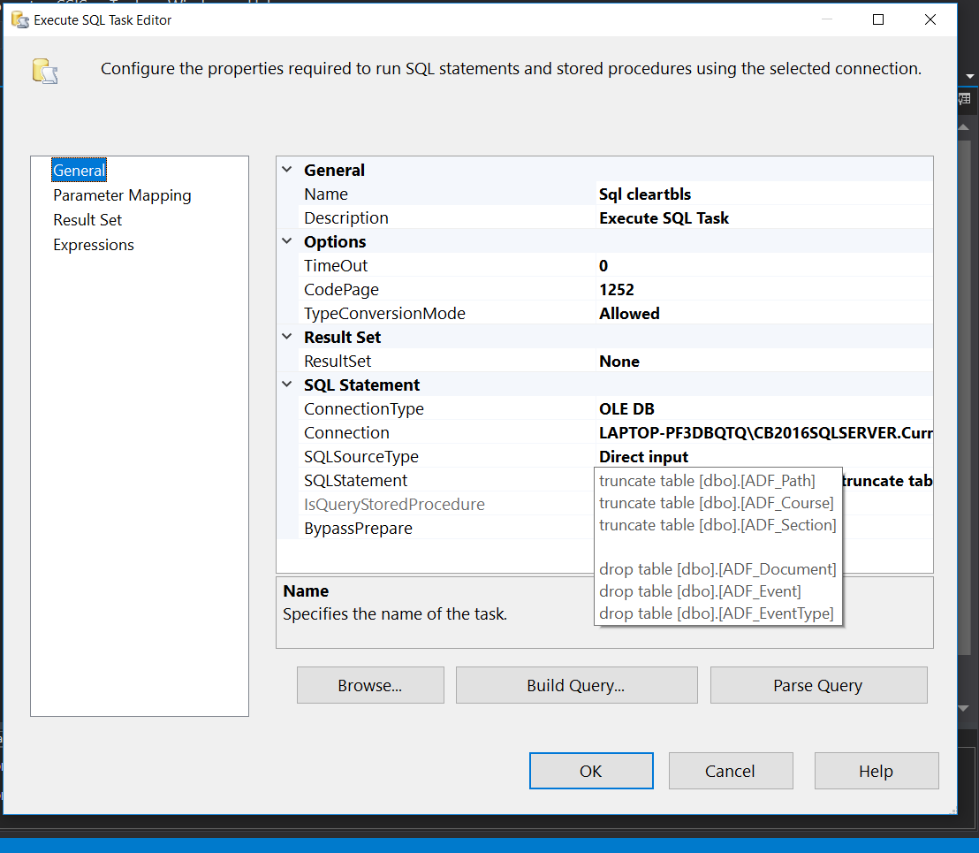

As We can see for Execute sql task we connect it to Curriculam database so it can access all tables from it. Also we added sql code to truncate and drop tables shown in SQLSTATEMENT tab.



Now we again use Execute sql task to execute sql query for created stored procedure and we put that at the end of that stack so our data flow task can run and load tables data first from excel files.

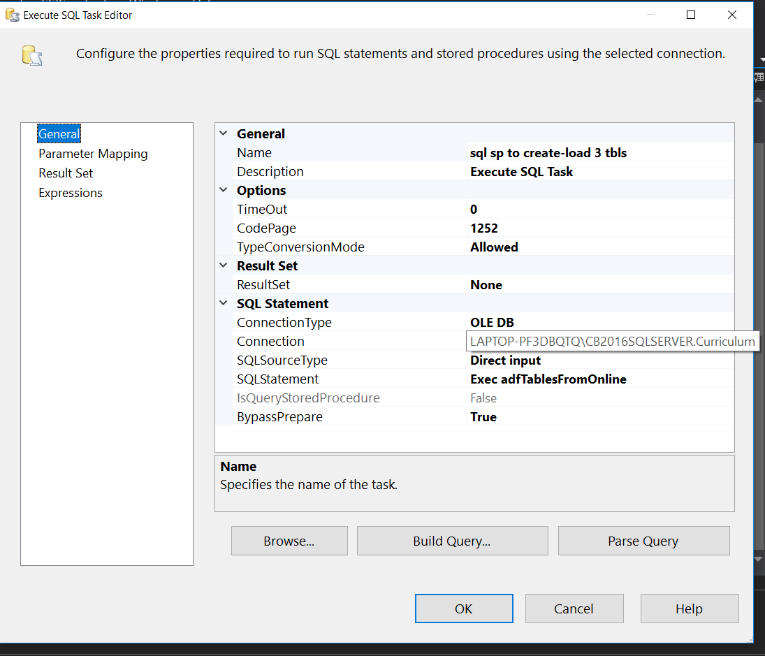

Execute sql task editor will run sql query “ EXEC adfTablesFromOnline “ for Curriculam database.

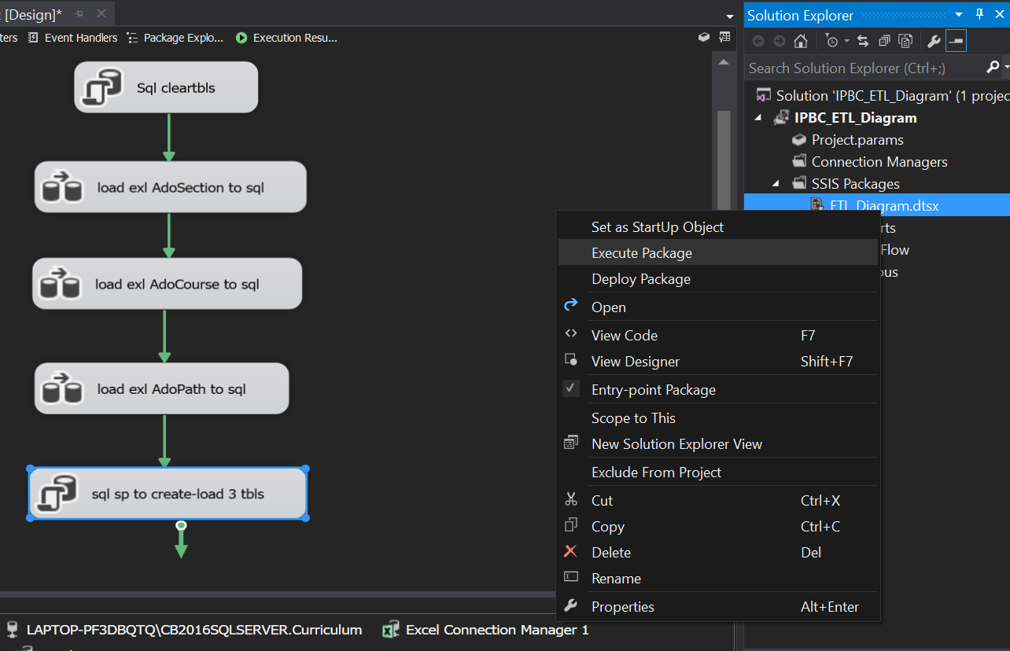

Now we can execute whole package to load 6 tables with right click on package and select execute.

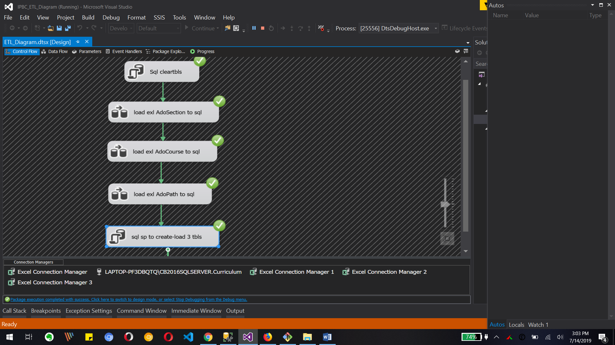

The above image shows that all task has been executed successfully.

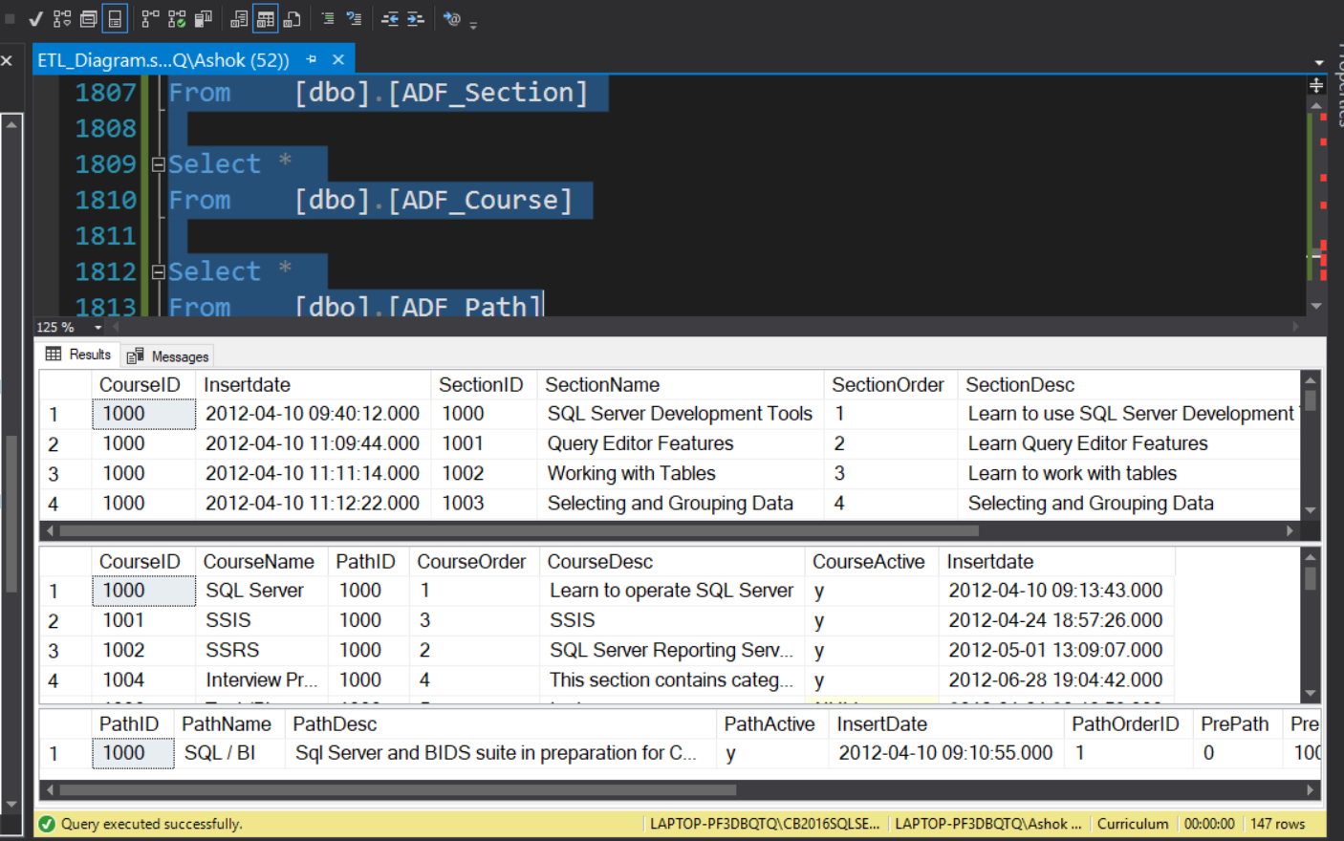

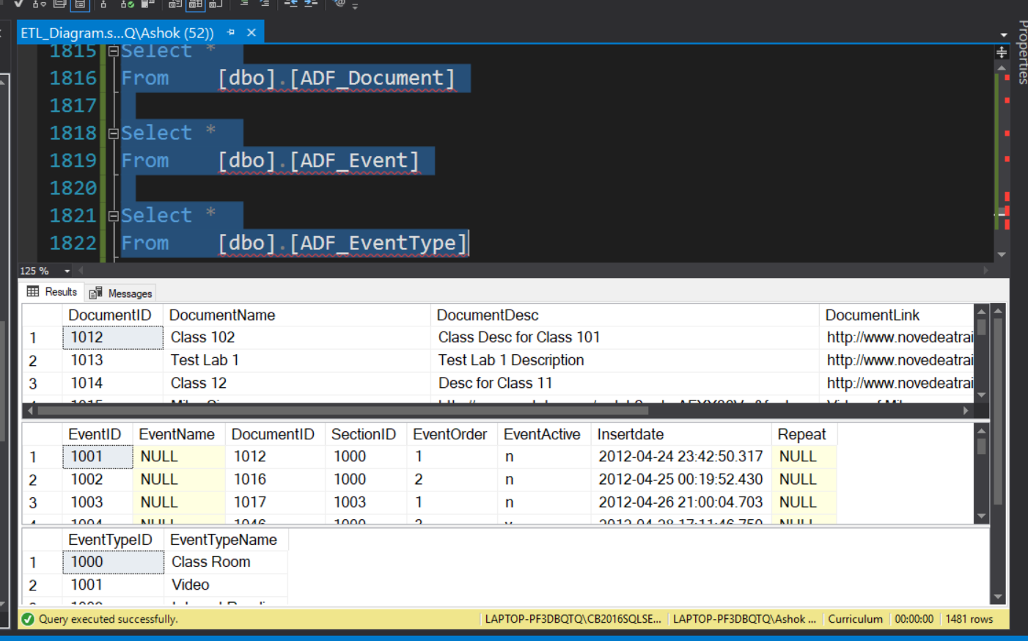

We can do Select * from all created table to see the data from them in SSMS. Above image shows that we have successfully loaded data from excel file and stored procedure with using SSIS package.

What to Submit:

1. Copy and paste the link to your video(s) as part of your homework.

1. SQL BI Interview Questions: SQL – What’s the difference between DELETE and TRUNCATE

<https://app.colaberry.com/app/ipbc/videos?user=31221&category=24>

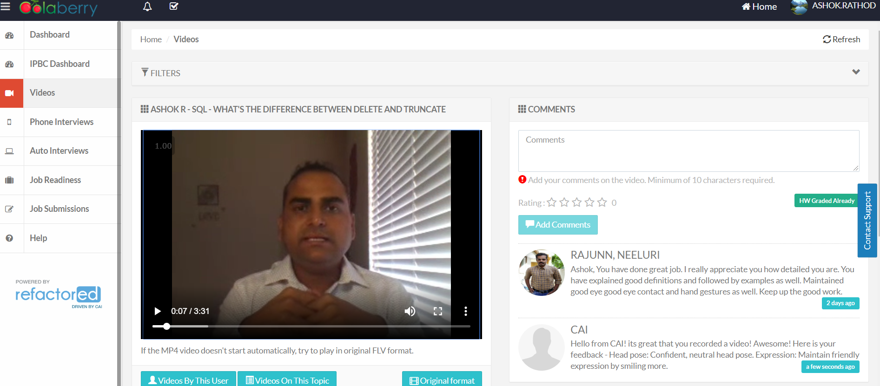

2. Watch, Comment &amp; take screenshots of your comments from 3 other videos on the same

topic (per question). Comments must be 20+ characters. Leave comments based on

presentation, delivery and/or technical details. Your critiques will help you be more

conscious of your own videos. (3 comment screenshots per Video Question)

